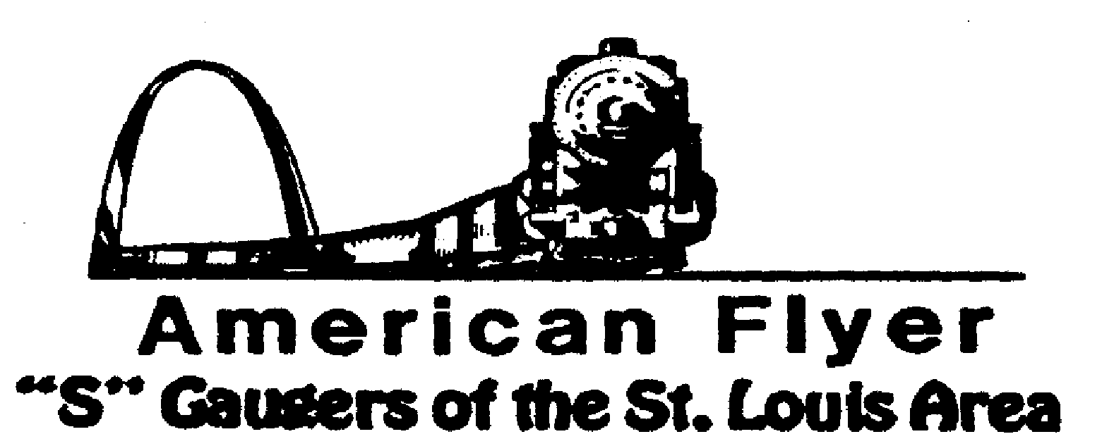

Website: www.trainweb.org/afsgsla/ E-Mail: afsgsla65@gmail.com
______________________________________________________
AFSGSLA LETTER
March 2022

Passing of Morris Berk III
It is with extreme sadness that we must pass along the following news. Our beloved founder and past
coordinator lost his long and painful fight with pancreatic cancer on Saturday, March 11. 2002. Please
see the obituary elsewhere in this newsletter, but we wish to share the following with you.

Wake (Visitation) Wednesday 3/16/2022 4:00 pm to 8:00 pm Collier’s Funeral Home
3400 N. Lindbergh Blvd.
St. Ann, MO 63074

Funeral Mass Thursday 3/17/2022 10:00 am at Our Lady of the Pillar Church
401 S. Lindbergh Blvd
St. Louis, MO 63131

Interment Thursday 3/17/2022 following Mass at St. Mary’s Cemetery
5150 Fee Fee Road

AFSGSLA Club Events and Related Activities:
Events are slowing down again due to the rise in COVID cases. Several AFSGSLA members have had it and we are happy to report that we are not aware of any serious complications.

As with the last several newsletters, we are combining the planned club events and the other related activities. Although we will not necessarily participate in some of the following events as a club, they are included in this somewhat comprehensive listing for your information. We suggest you keep this newsletter for your future reference and attend our club meetings for full details.

Actual Scheduled Events (obviously subject to change at the whim of some government official)

Friday, April 22, 2022: THIS IS UNCONFIRMED – Club meeting hosted by Joel Weber. Unconfirmed due to urgency of getting this newsletter out with Moe’s funeral details.
Saturday, May 14, 2022: After the storm train show at Meramec Elks Hall, 10 a.m. to 2 p.m. It is located at 1515 Miller Road in Imperial, MO 63052. $3.00 at the door. And no, it is not far at least for us South County guys. It is only one exit after MO 141.
Saturday May 14, 2022: THIS IS UNCONFIRMED – Club meeting hosted by Bob Mueling. Unconfirmed due to urgency of getting this newsletter out with Moe’s funeral details.
August 12, 13 &14, 2022: NMRA convention in Collinsville, Illinois. There is the possibility to display our sectional layout for the 3-day show, this would be for exposure only, there would be no compensation. A decision has not yet been made, but we are leaning to declining.
September 2022: Cliff Saxton once again reserved September for a club meeting.
Saturday and Sunday, October 8 & 9, 2022: Mississippi Valley N Scalers (MVNS) show at the Kirkwood Community Center, Kirkwood MO. No word yet on whether we will be displaying our sectional layout this year.

What’s been happening?

Saturday and Sunday, January 29 -30, 2022: Great Train Show, St. Charles Convention center. We displayed our sectional layout. Barry Dolan coordinated.
February 20200: We displayed our sectional layout at the National Museum of Transport.

This and That

Moe’s Obituary:
MORRIS “Moe” BERK III died March 12, 2022 at the age of 82. Moe was born in Chicago on June 26, 1939 to the late Morris Berk, Jr. and the late Dorothy (Vinton) Berk Luedtke. He grew up in Flossmoor, Illinois and proudly achieved Eagle Scout. He was married for 58 years to “the little girl down the street” and is survived by his wife and faithful life partner, Rita (Dolan) Berk. He was the stepson of the late Franklin G. Luedtke of Flossmoor, IL and is survived by his sister Marian D. Schouten (Richard) of Homer Glen, IL; brother Gregory C. Berk (Donna) of Geneva, IL; and daughters Mary E. Berk of Troy, MO; Ann M. LaRue (Dennis) of Chesterfield MO; Karen P. Kalka (Randy) of Jacksonville, FL; granddaughters Margaret Kalka, Kimberly LaRue, Marissa LaRue, grandson Reese Kalka; and numerus nephews, nieces, and cousins.
Moe graduated from Mendel Catholic H.S. (Chicago) in 1957, St. Mary’s University (Winona, MN) with a B.A. in Math and Science in 1961, Purdue University (W. Lafayette, IN) with a B.S.C.E. in Civil Engineering in 1962, and Purdue University with a M.S.C.E. in Civil (Geotechnical) Engineering in 1963. He was a life-long learner, very proud of his academic achievements, and always stressed the importance of education to his family.
Moe retired with almost 50 years of service as an engineer on design and heavy construction projects. Although, his experience was primarily on projects in the Midwest, he was frequently assigned to projects throughout North America. He was a registered Professional Engineer (in multiple states), Land Surveyor, Certified Geotechnical Engineer, and was a recognized Expert Witness. For the last 10 years of his career, he was the supervising engineer on the design and construction of the St. Louis Light-Rail Commuter Railroad System and fulfilled his life-long fascination with railroads.
Throughout the years, Moe was able to travel extensively with Rita and their daughters throughout the U.S. He was a devoted Catholic and always sought out ways to serve his church and the St. Louis institutions providing Catholic education. Moe looked forward to annually attending the White House Retreat in St. Louis, MO, with fellow Christian men for almost 50 years. He served as the President of his community association over 24 years and continued with his long-term involvement in the model railroad hobby.

St. Louis Lionel Railroad Club – The club has vacated the building at the end of October. What was salvaged was put in a storage locker until a new location can be found. Unfortunately the storage locker was broken into and the club lost an estimated amount of $15,000 in club cars and equipment.
2024 Fall S Fest Report – The steering committee met to discuss the feasibility of the AFSGSLA hosting the Fall S Fest at its next scheduled date, sometime in the fall of 2023. No decision has been made, or will be made, until a thorough analysis has been made, especially the cost aspect, and how much we could potentially “be on the hook” for. With the exception of the 2021 SFEST held last year, all previous SFEST have been profitable. The problem with last year centered arounf having it a year later and not passing on the 2021 cost increases.
'
2022 Fall S Fest – As of now, there is no 2022 S Fest scheduled. Unfortunately, State Line had to decline sponsoring it. The 2023 S Fest in Chicago is currently a go. As of this writing, it is assumed that there will be no 2022 S Fest.

Midwest Money Layout Open House - Sponsored by the Midwest Money Company, on the First Sunday of every month from 11:00 A.M.to 4: P.M. They are located at 5901 Hampton, St. Louis MO just across Holly Hills Street. The layout is rather large, fully developed scenery 3 rail O-Scale layout. This rather large layout may be one of only a very few which can be claimed to be 100% complete. This location is in South St. Louis City, roughly halfway between Chippewa and Gravois

Special notice from David Stevens: Dave has had it easy recently, but as you can see, we are hoping to get back to in person club meetings now in 2022. We have had a number of our faithful club members who have volunteered to host future meetings. Although our David Stevens is especially pleased with the excellent response to his recent requests, he tells us that we still need club members to volunteer to host club meeting in the future. He states that if you have not hosted a meeting recently---or ever---please carefully consider doing so. It is a great way to “pay your dues” and it really is not much trouble to host a club meeting (the club pays our host a modest fee to offset expenses for refreshments). We have often said (and our hosts have agreed) that there is no surer way of getting your train room shaped up then hosting a club meeting. David Stevens will help you with the details, if you just contact him at Telephone: 314/ 921-1127 or stevens8128@sbcglobal.net.

Notes from your Co-Coordinators!

TOM SCHNUR
AFSGSLA Co-Coordinator
afsgsla65@gmail.com

RICK ARCHESKI
AFSGSLA Co-Coordinator
rcheski@charter.net

That’s it for now, more later:
GARY MUELLER
AFSGSLA Newsletter Editor
gmatmueller@aol.com

-And remember, “It’s just for the fun of it!”

